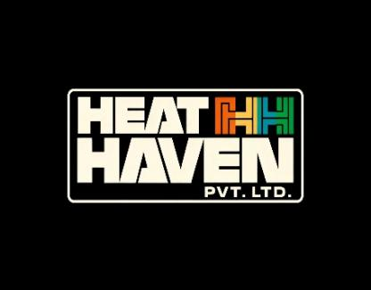
HeatHaven Pvt.Ltd
INTERNSHIP COMPLETION CERTIFICATE

This is to certify that Mr. Kanishak Choudhary , has successfully completed his IT Internship at HeatHaven for a period of two (02) months, from 1st October 2025 to 1st December 2025 .
During the internship, he worked on various Information Technology–related tasks, including system support, basic software development, data handling, documentation, and understanding organizational IT workflows. He showed strong technical aptitude, problem-solving skills, and a keen interest in learning new technologies.
His dedication, discipline, and professional conduct throughout the internship period were commendable. We found his performance to be sincere and satisfactory.
We wish him every success in his future academic pursuits and professional career in the field of Information Technology.
For HeatHaven

Authorized Signature
Name: Pulkit Bhatnagar
Designation: Owner
Date: 1st December 2025
Place: Dwarka, New Delhi-110059

